Projektantrag

Titel: | Domain-specific GraphRAG pipeline with model fine-tuning
Autoren: | Marco Allenspach, Lukas Koller, Emanuel Sovrano
Ziele der Arbeit | Was soll erreicht werden?  - Graph-basiertes RAG  - Model Finetuning  - Automation
Kurzbeschreibung: | Die drei Schwerpunkte des Projekts sind die komplette Extraktion der Inhalte aus ca. 50 PDFs, die Erstellung eines dichten Graphs und das fintuning anhand des Graphs resp. Des graphbasierten RAGs.  - Docling  [2501.17887] Docling: An Efficient Open-Source  Toolkit for AI-driven Document Conversion  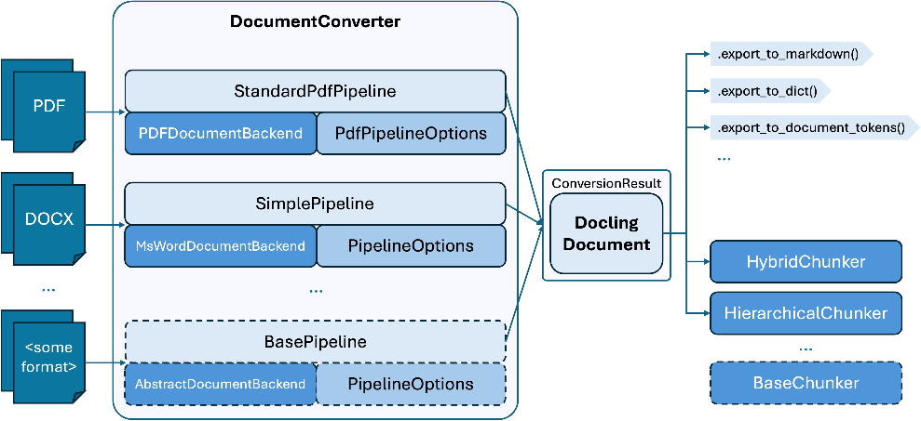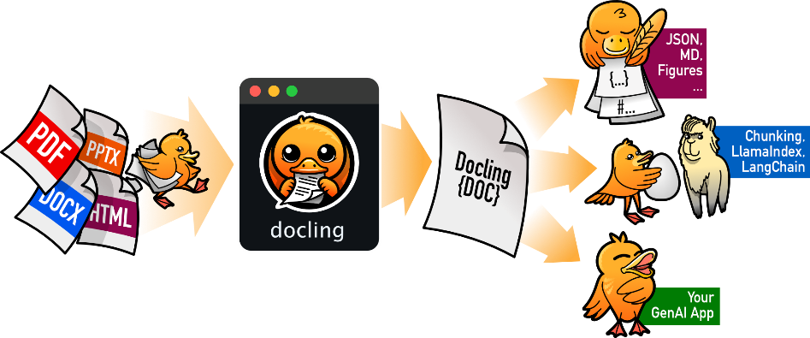  - LeanRAG (mit Graph)  [2508.10391] LeanRAG: Knowledge-Graph-Based Generation  with Semantic Aggregation and Hierarchical Retrieval  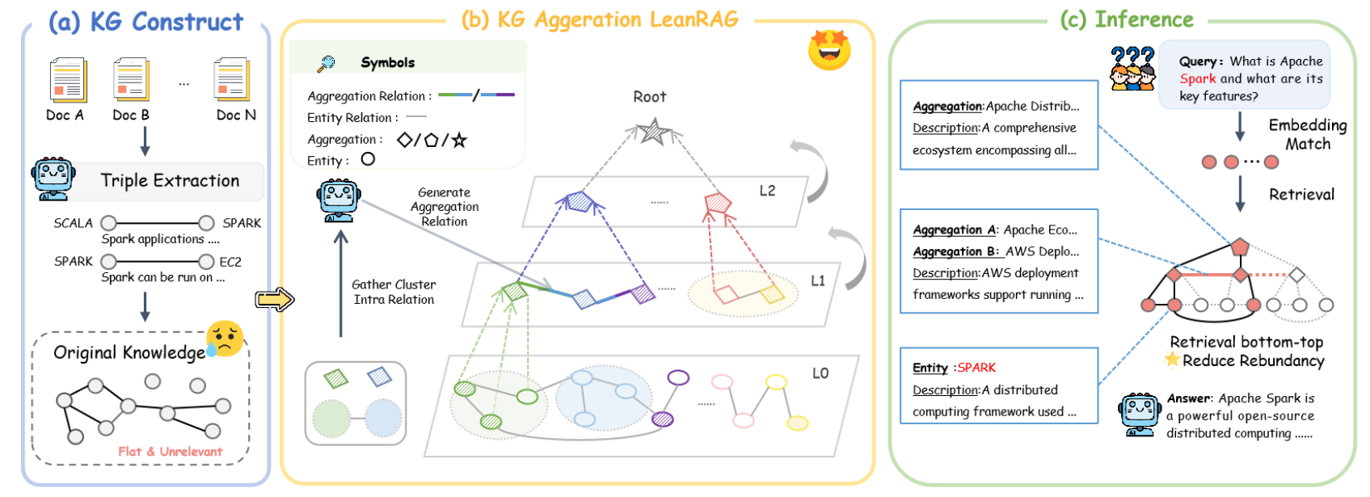  - 0SS20b finetuning von OpenAI oder mit z.B. ein kleines Qwen-Model mit einem etablierten Framework.  🦥Unsloth Docs  Train your own model with Unsloth, an open-source framework for LLM fine-tuning and reinforcement learning.  At Unsloth, our mission is to make AI as accurate and accessible as possible. Train, run, evaluate and save gpt-oss, Llama, DeepSeek, TTS, Qwen, Mistral, Gemma LLMs 2x faster with 70% less VRAM.  [2504.05478] GraphRAFT: Retrieval Augmented Fine-Tuning for Knowledge Graphs on Graph Databases  [2510.09580] GraphMERT: Efficient and Scalable Distillation of Reliable Knowledge Graphs from Unstructured Data  Die vielversprechende Ergebnisse von GraphMERT unterstreichen den graph-basierten Ansatz, bei dem ein 80M domänenspezifisch Model ein GPT5 übertreffen kann.
Rahmenbedingungen: | Sämtliche Scope Limitierungen (Hardware, etc.)  - 1x 4090er mobile  - 1x M3pro 24GB shared  - 1x 4090er Desktop  - 1x 5060TI Desktop  - Backup: Online Provider
Datenquelle | Welches Dataset soll verwendet werden?  Open RAG Bench Dataset  Open RAG Benchmark (1000 PDFs, 3000 Queries): A Multimodal PDF Dataset for Comprehensive RAG Evaluation  What sets our dataset apart is its unparalleled focus on pure PDF content, meticulously extracting and generating queries on diverse modalities including text, tables, and images. This allows for a comprehensive assessment of RAG systems' ability to process and synthesize information across different data types, even when they are intricately interwoven within a document.  Documents: 1000 PDF papers evenly distributed across all Arxiv categories.  400 positive documents (i.e., each one is the golden document for some queries)  600 hard negative documents (i.e., they are completely irrelevant to all queries)  https://github.com/vectara/open-rag-bench  gpahal/pdf-rag-embed-bench  This is a benchmark for PDF RAG embedding systems. Given a bunch of PDFs, I try to measure the performance of different embedding models - from text to multimodal to multi vector and a combination of them.  Topics: Academic, Administration, Finance, Law, Manual, News, Textbook  https://github.com/gpahal/pdf-rag-embed-bench  PubMedQA  The task of PubMedQA is to answer research questions with yes/no/maybe (e.g.: Do preoperative statins reduce atrial fibrillation after coronary artery bypass grafting?) using the corresponding abstracts.  https://pubmedqa.github.io/  https://github.com/pubmedqa/pubmedqa  https://huggingface.co/datasets/qiaojin/PubMedQA
Risiken | Sämtliche Risiken & Optimierungsstrategien  - Die resultierenden Graphen haben nicht die ausreichende Qualität, um einen Unterschied zu machen  - Das Finetuning ist zu Ressourcenintensiv  - Koordination im Dreier-Team

